Chapter 5, Solution 39

For the op amp circuit in Fig. 5.76, determine the value of v₂ in order to make
v_{o} = –16.5 V.

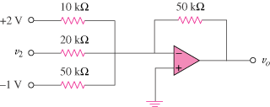

Figure 5.76
For Prob. 5.39.

Solution

This is a summing amplifier.

Thus,

